EXPERIMENT NO. 8

WHITE BOX TESTING

Aim

To design test cases for performing white box testing for University Exam Scheduling.

Description

White box testing, also called glass box testing is a testing technique which exercises the internal logic of software components. Using white box testing, the software engineer can derive test cases that
- Guarantee that all independent paths within a module have been exercised at least once.
- Exercise all logical decisions on their true and false sides.
- Execute all loops at their boundaries
- Exercise internal data structures to ensure their validity.

Different types of White Box Testing techniques are:

- Basis Path Testing

Basis path testing is a white-box testing technique first proposed by Tom McCabe. Basis path method enables to derive a logical complexity measure of a procedural design and use this measure as a guide for defining a basis set of execution paths. Test Cases derived to exercise the basis set are guaranteed to execute every statement in the program at least one time during testing. The flow graph depicts logical control flow within a program. The following steps constitute basis path testing.

Step1: Map flowchart into a corresponding flow graph

- Each circle, called a flow graph node, which represents one or more procedural statements.
- A sequence of process boxes and a decision diamond can map into a single node.
- The arrows on the flow graph, called edges or links, represent flow of control and are analogous to flowchart arrows.
- Areas bounded by edges and nodes are called regions.

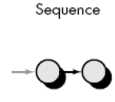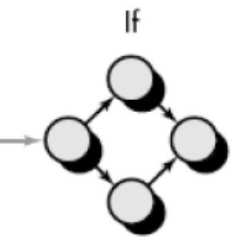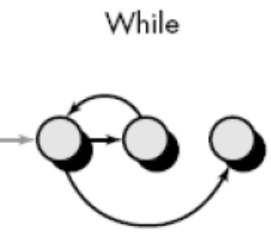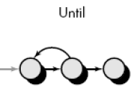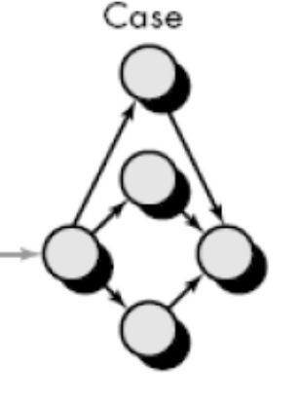
Figure 8.1 Flow graph notations

- When counting regions, we include the area outside the graph as a region.
- Each node that contains a condition is called a predicate node and is characterized by two or more edges emanating from it.

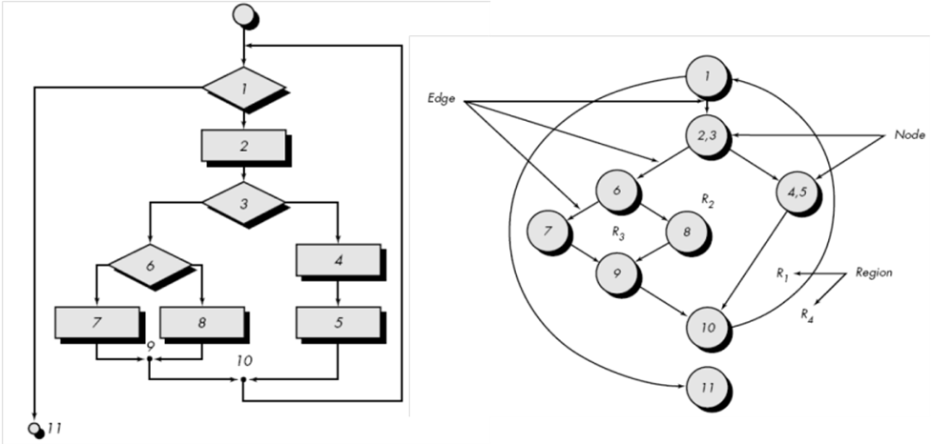
Figure 8.2 Example flowchart and corresponding flow graph

Step 2 : Compute the cyclomatic complexity CC
- Cyclomatic complexity is a software metric that provides a quantitative measure of the logical complexity of a program.
- The value computed for cyclomatic complexity defines the number of independent paths in the program.
- Hence gives the number of test cases to ensure that all statements have been executed at least once.
- An independent path is any path through the program that introduces at least one new set of processing statements or a new condition.

Complexity is computed in one of three ways:
- The regions formed in the flow graph correspond to cyclomatic complexity.
- Cyclomatic complexity, V(G), for a flow graph, G, is defined as
V(G) = E - N + 2
where E is the number of flow graph edges, N is the number of flow graph nodes.
- Cyclomatic complexity, V(G), for a flow graph, G, is also defined as
V(G) = P + 1
where P is the number of predicate nodes contained in the flow graph G.
For the example in Figure 8.2 above,
- The flow graph has four regions.
- V(G) = 11 edges - 9 nodes + 2 = 4.
- V(G) = 3 predicate nodes + 1 = 4.

Step 3: Determine a basis set (set of independent paths)
- path 1: 1-11
- path 2: 1-2-3-4-5-10-1-11
- path 3: 1-2-3-6-8-9-10-1-11
- path 4: 1-2-3-6-7-9-10-1-11

Step 4: Prepare test cases that will force execution through each of the basis paths

- Control Structure Testing
Control structure testing is more comprehensive than basis path testing. This method uses different categories of tests that are listed below.
- Condition testing (e.g. branch testing) focuses on testing each decision statement in a software module. It is important to ensure coverage of all logical combinations of data that may be processed by the module (a truth table may be helpful).
- Data flow testing selects test paths based according to the locations of variable definitions and uses in the program (e.g. definition use chains).
- Loop testing focuses on the validity of the program loop constructs (i.e. while, for, go to).

- Condition testing
Conditional testing strategy can be applied to the different types of conditions that are possible which are listed below.
- Compound conditions
2 or more simple conditions connected with AND, OR.
Eg : (a>b) AND (c<d)
- Relational expression
(E1 rel-op E2) ;E1, E2 --→ arithmetic expr.
Eg : (a*b+c) > (a+b+c)

- Boolean expression
(B1 AND B2)

Condition testing strategies are described below.
- Branch Testing
- It is the simplest condition testing strategy.
- For a compound condition C, the true and false branches of C and every simple condition need to be executed at least once.
- Eg : if ( a>0 && b== null )
condition coverage can be achieved by testing with
a=1 b != null
a=1 b = null
a=0 b != null
a=0 b = null

- Domain testing
- For a relational expression, 3 tests are required:
Eg : E1<Rel-op>E2
3 test cases are:
1. E1<E2
2. E1>E2
3. E1=E2
If relational operator is incorrect , all 3 tests guarantee detection of relational operator error.

- Branch and relational operator testing
- Branch and Relational Operator Testing – uses condition constraints
Example 1:
C1: B1 & B2
Where B1, B2 are boolean conditions
Condition constraint of form D1, D2 where D1 and D2 can be true (t) or false (f)
The branch and relational operator test requires the constraint set { (t,t), (f,t), (t,f) } to be covered by the execution of C1

Example 2:
C2: B1 & (E3=E4)
B1 - boolean expr
E3, E4 - arithmetic expr
Condition constraint of C2 is (D1, D2)
D1- (t/f)
D2- >,=,<
Hence the constraint set for C2 is
(t,t)------→ (t,=)
(t,f)----→ (t,<) and (t,>)
(f,t)---→ (f,=)

Example 3:
C3: (E1>E2) & (E3=E4)
E1,E2,E3,E4 ---arithmetic expr.
Constraint set for C3----→
{ (>,=) (=,=) (<,=) (>,>) (>,<) }
(t,t) (f,t) (f,t) (t,f) (t,f)

- Data Flow testing
- Data flow testing selects test paths of a program according to the locations of definitions and uses of variables in the program.
- A USE is a reference to a variable’s value. A DEF is an assignment of a new value to the variable.
- A DEF-USE pair (DU chain) is a path from the point the variable is defined to the point the variable is referenced. Data flow testing requires that all DEF-USE pairs to be executed.

Example 1
if(some_exp) //1
some_var=1; //2
else //3
some_var=2; //4
If(some_case) //5
P1(some_var); //6
else //7
P2(some_var); //8
- DEF: 2 and 4
USE : 6 and 8

4 DEF-USE pairs ----→
DEF-USE-Paths DEF USE PATH
1 2 6 <1-2-5-6>
2 2 8 <1-2-5-8>
3 4 6 <1-4-5-6>
4 4 8 <1-4-5-8>
Test Cases :
(some_exp=true, some_case=true) path 1
(some_exp=true, some_case=false) path 2
(some_exp=false, some_case=true) path 3
(some_exp=false, some_case=false) path 4

Example 2

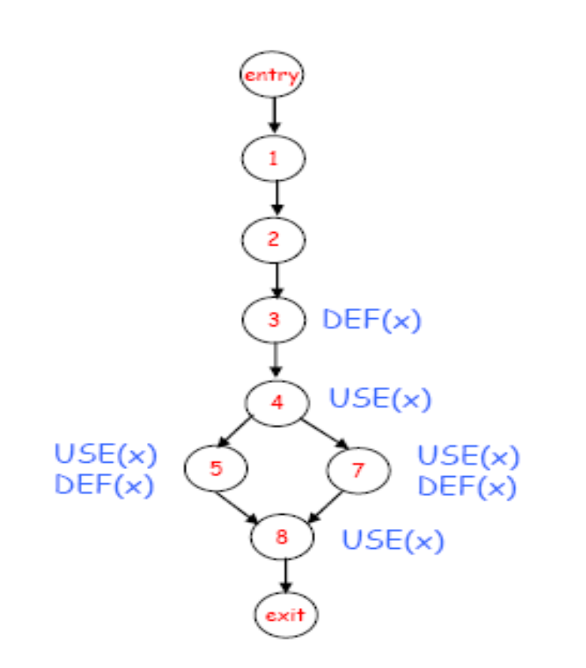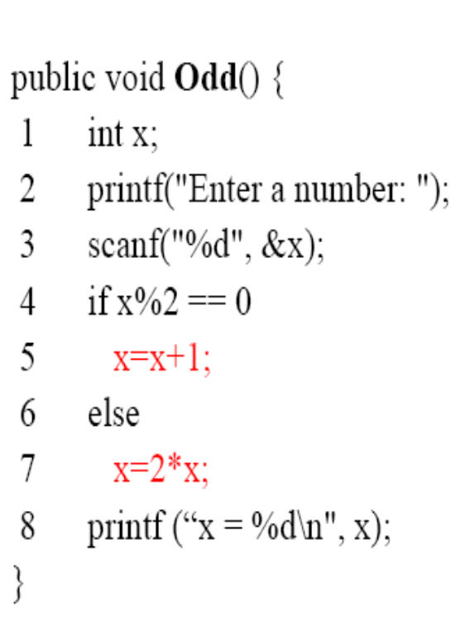
Figure 8.3 Example for Data Flow Testing
- DU Chains of the Odd() Example
– (x, 3, 4), (x, 3, 5), (x, 3, 7)
– (x, 5, 8), (x, 7, 8)
NOTE : (x, 3, 8) is NOT a DU chain since the value of x at Line 3 is redefined at Lines 5 and 7 before it reaches the use at Line 8
Test paths selected according to all use coverage:
path1 1-2-3-4-7-8 cover (x, 3, 4), (x, 3, 7), (x, 7, 8)
path2 1-2-3-4-5-8 cover (x, 3, 4), (x, 3, 5), (x, 5, 8)

- Loop Testing
Loop Testing is a white box testing technique that focuses exclusively on the validity of loop constructs. Four classes of loops can be defined:
- Simple loops
- Concatenated loops
- Nested loops
- Unstructured loops.
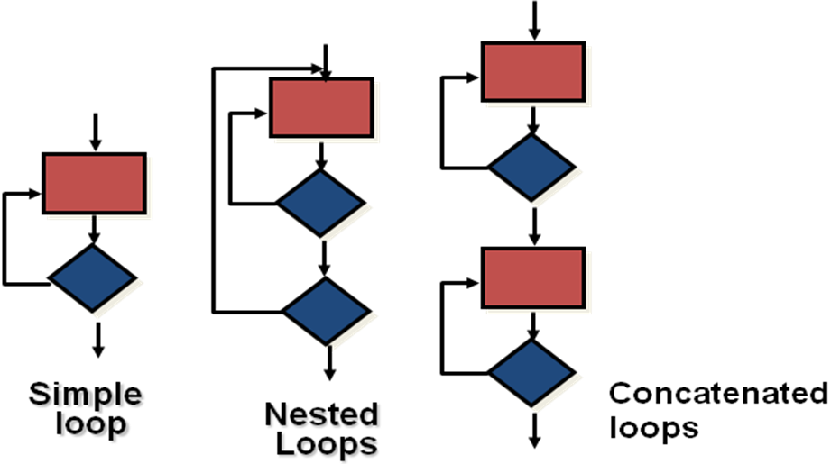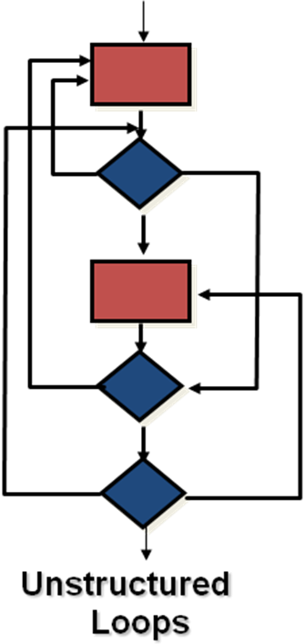

Figure 8.4 Different types of loops

- Testing simple loops
The following sets of tests can be applied to simple loops, where ‘n’ is the maximum number of allowable passes through the loop.
1. Skip the loop entirely.
2. Only one pass through the loop.
3. Two passes through the loop.
4. ‘m’ passes through the loop where m is less than n.
5. n-1, n, n+1 passes through the loop.

- Nested Loops
If we extend the test approach from simple loops to nested loops, the number of possible tests would grow geometrically as the level of nesting increases.
1. Start at the innermost loop. Set all other loops to minimum values.
2. Conduct simple loop tests for the innermost loop while holding the outer loops at their minimum iteration parameter values.
3. Work outward, conducting tests for the next loop, but keep all other outer loops at minimum values and other nested loops to "typical" values.
4. Continue until all loops have been tested.

- Concatenated Loops
Concatenated loops can be tested using the approach defined for simple loops, if each of the loops is independent of the other.
However, if two loops are concatenated and the loop counter for loop 1 is used as the initial value for loop 2, then the loops are not independent. In this case, treat them as nested loops and perform testing.

- Unstructured Loops
Whenever possible, this class of loops should be redesigned to reflect the use of the structured programming constructs.

Conclusion

Hence, based on what we learnt from this experiment; we were able to understand how to perform White Box Testing on our project.
The tests used are mentioned below

    - “Process File 1” component maps to “Validate File 1” module and its subtree.
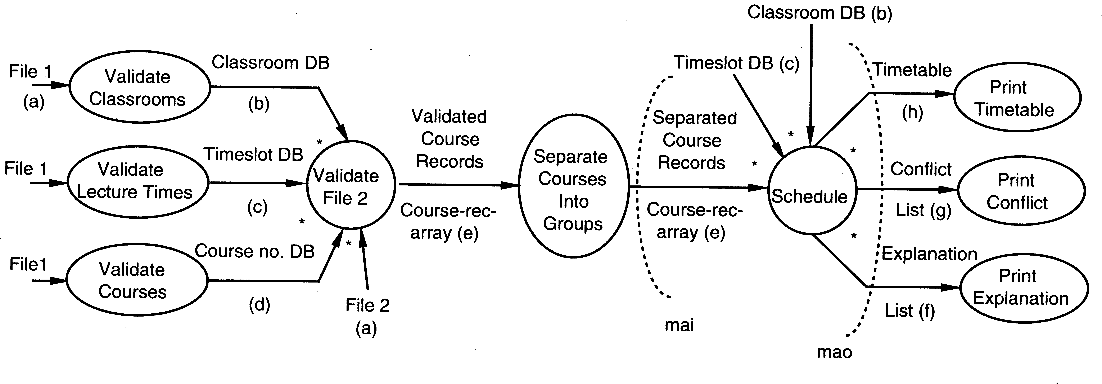

Figure 1: Data flow diagram for the case study

“Process File 2” component maps to “Validate File 2” and “Separate Courses” modules (and their subtrees).
•
“Schedule the courses” components map to the “Schedule” and “Output” modules (and their subtrees)
•
The pipes in the architecture are implemented in this design by the parameter passing mechanism.
•

Cyclomatic Complexity

M = E – N + 2P
where,
E = the number of edges in the control flow graph
N = the number of nodes in the control flow graph
P = the number of connected components

Therefore Cyclomatic Complexity = E – N + 2P
= 9 – 14 + 2(8)
= 11

